Implying that other methods of travel will lead to your impending doom is a bit misleading. But, now that I have your attention, FLYING IS THE SAFEST MODE OF TRAVEL. I say that as a consumer of airline travel and as an employee of a major airline company. There has been a lot of negative attention as a result of the CNN article published regarding the 2018 engine failure with Southwest flight 1380. I'm hear to explain why the negative press is unwarranted using empirical data I've compiled while working for Southwest airlines. To begin, examine the following infographic:

[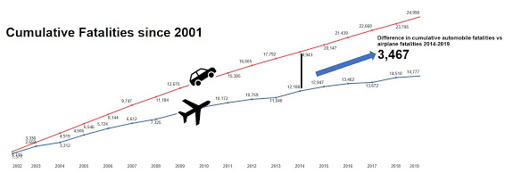](https://1.bp.blogspot.com/-3RsDMg-qc3o/YB7x1xODknI/AAAAAAAAD84/X5qvpgHI8lksufbHmDloaKlhSce7IQmsQCLcBGAsYHQ/s1572/MainInfo.JPG)

Notice the number of deaths over time since 2001. The gap between the lines continues to widen as more automobile accidents occur per year than airplane accidents. Since 2014, there have been 3,467 more automobile accident related fatalities than airplane related fatalities. In fact, your odds of dying in a car crash are 1 in 114, while your odds of dying in a plane crash are 1 in 9,821." That means you have 1 in 16 million chance of  dying on a flight [1]. Take the below image for example.

[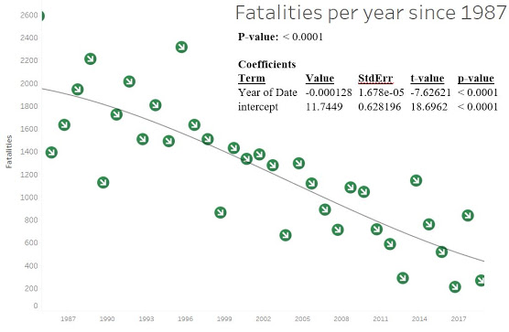](https://1.bp.blogspot.com/-9d2Jzc9cAac/YB73NA0hkVI/AAAAAAAAD9E/WqpFmJikToU2JlBOZIJ3cHTtyOvRS4InwCLcBGAsYHQ/s1033/univariant.JPG)

Yes, it is a univariant analysis, but clearly with a statistically significant p-value, flights have gotten safer over time. The number of fatalities continues to trend downward!

You’re thinking “so what, I feel in control when I drive”. Does it change your mind that car fatalities account for 65% of all fatalities when compared to airplanes?

[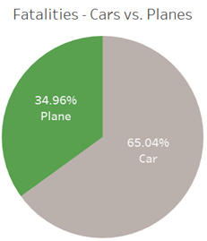](https://lh3.googleusercontent.com/-s5gCKVW_8fY/YB8OaTIB-oI/AAAAAAAAD-E/e8zKdXKHzXw-_cwte_VIncz67vFtVNrOQCLcBGAsYHQ/image.png)

Ok, so we've seen the overall trends, but how about major airline trends? Is there cause for concern when I fly with Southwest?

[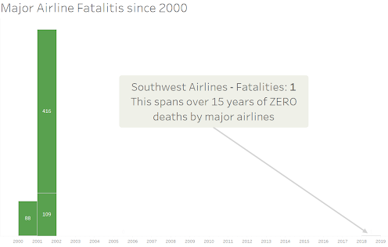](https://lh3.googleusercontent.com/-ctrcOaClkHk/YB747BPQgwI/AAAAAAAAD9c/Du5pOARU8-EhGYE_ElwV2j43NHFJuidzQCLcBGAsYHQ/image.png)

There has been a single fatality on major US airlines since 2002, and it is the 1 fatality that occurred in 2018 and was reported by CNN. Prior to that, the deaths in 2001 were related to the terrorist attacks that occurred on 911.

So airlines are safer, so what? Why should you care? Negative media attention impacts how customers view a product. Airline's product are their flights. Do you like paying the lowest possible fare for your ticket to Disney World? If less people are flying, that means less revenue for the airline. If the airline isn't gaining revenue, they still have to cover expenses that meet federal aviation standards. Expenses don't go down just because people aren't flying. Take the next two graphics for example.

[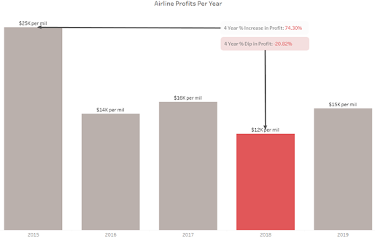](https://lh3.googleusercontent.com/-rFEDUP5cRsU/YB8Ib2IhGpI/AAAAAAAAD9s/uqKsxtjKJWoNpipqyqxCz0hmlfIIaY62gCLcBGAsYHQ/image.png)

It is no coincidence that 2018 saw the lowest profits in the last four years. The CNN story didn't cause the dip, but the general public sentiment of airplane safety may have. In fact, less people flew on airplanes in 2019 than any other year within the last four years:

[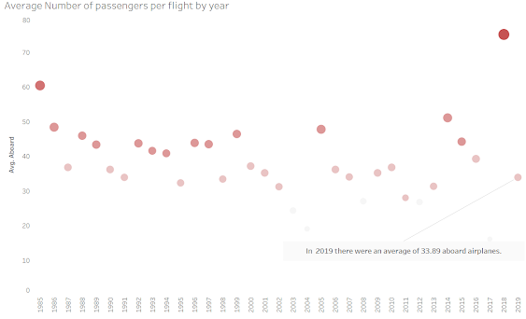](https://lh3.googleusercontent.com/-04ohRsAlq-k/YB8LXDieBiI/AAAAAAAAD94/clgviRvXUcEC0179FQj5LVmCX9pZla5uQCLcBGAsYHQ/image.png)

In other words, if you like to fly on a budget, this shift in negative attention should bother you. In fact, you should speak out, post these positive graphics to your social media page. Are you a stakeholder in rental property or do you own an Airbnb? If people aren't traveling as much, your bottom line could also be impacted. Partner with airlines to advertise the safety of flying!

Again, this blog title may embellish overall traveling safety a bit. But the general sentiment holds true. Flying is safer than any other mode of transportation. If you like traveling at a low cost, push back on the negative media attention. Post this blog and the graphics on your social media page. Partner with airlines to highlight the safety of flying. These steps will restore the public trust in flight safety and keep prices at bay for travelers.

[1] https://www.lifesavvy.com/12075/is-flying-really-safer-than-driving/#:~:text=Still%2C%20your%20odds%20of%20dying,private%20planes%2C%20not%20commercial%20flights.

https://www.kaggle.com/kevinjames1993/fatal-crashes-fatalities?select=ardd_fatal_crashes.csv

https://www.airlines.org/data/

https://www.kaggle.com/cgurkan/airplane-crash-data-since-1908

https://www.airlines.org/dataset/annual-results-world-airlines/

https://www.kaggle.com/cgurkan/airplane-crash-data-since-1908

https://github.com/fivethirtyeight/data/tree/master/airline-safety

https://www.cnn.com/2019/01/02/health/plane-crash-deaths-intl/index.html